Row | State | Year AH | Tax (Tribute) Durhams | Type of Government | Source
1 | Azerbaijan+Arran+Armenia | 60 | 30,000,000 | Caliph Governor | Ya'qubi, n.d, 2/277
2 | Azerbaijan+Arran+Armenia | 169 | 4,000,000 | Caliph Governor+ Military Dominance | Ibn Khaldun, 1/226
3 | Azerbaijan+Arran+Armenia | 184 | 4,000,000 | Caliph Governor+ Military Dominance | Jahshiyārī, 362
4 | Armenia+Arran | 231 | 4,000,000 | Caliph Governor+ Military Dominance | Ibn Ḵhurdādbeh, 101
5 | Azerbaijan+Arran+Armenia | 278 | 4,000,000 | Sajids, Independent | Ya'qubi, nd, 2/272
6 | Armenia+a part o Arran | 316 | 4,000,000 | Military Dominance of Local Governor | Kātib al-Baghdādī, 149
7 | Arzan+Miafraghin | 316 | 4,200,000 | Military Dominance of Local Governor | Kateb Baghdadi, 165
8 | Azerbaijan+Arran+Armenia | 344 | 16,000,000 | Sallarids, Independent | Ibn Hawqal, 100
Table 2: Tax collection report of Arran and Armenia districts in different years
Row | District/City | District | Tribute (Cash) Dirham | Ruler
1 | Shirvan+Shaki | Arran | 1,000,000 | Ashjaniq + Abi Abdul Mak
2 | Internal Armenia | Armenia | 2,200,000 | Bani Sanbat
3 | Khachin | Armenia | 150,000 | Sankharib
4 | Jizan | Armenia | 400,000 | Abolghasem Jizani
5 | Vizvar | Unknown | 50,000 | Abolghasem Viszori
6 | Rob | Unknown | 300,000 | Sanharib (Ibn Sawada)
7 | Jazr | Arran | 200,000 | Vashghan bin Musa
8 | Va+Vostan | Armeinia | 100,000 | Bani al-Dirani
Table 3: Tribute collection report of Arran and Armenia districts

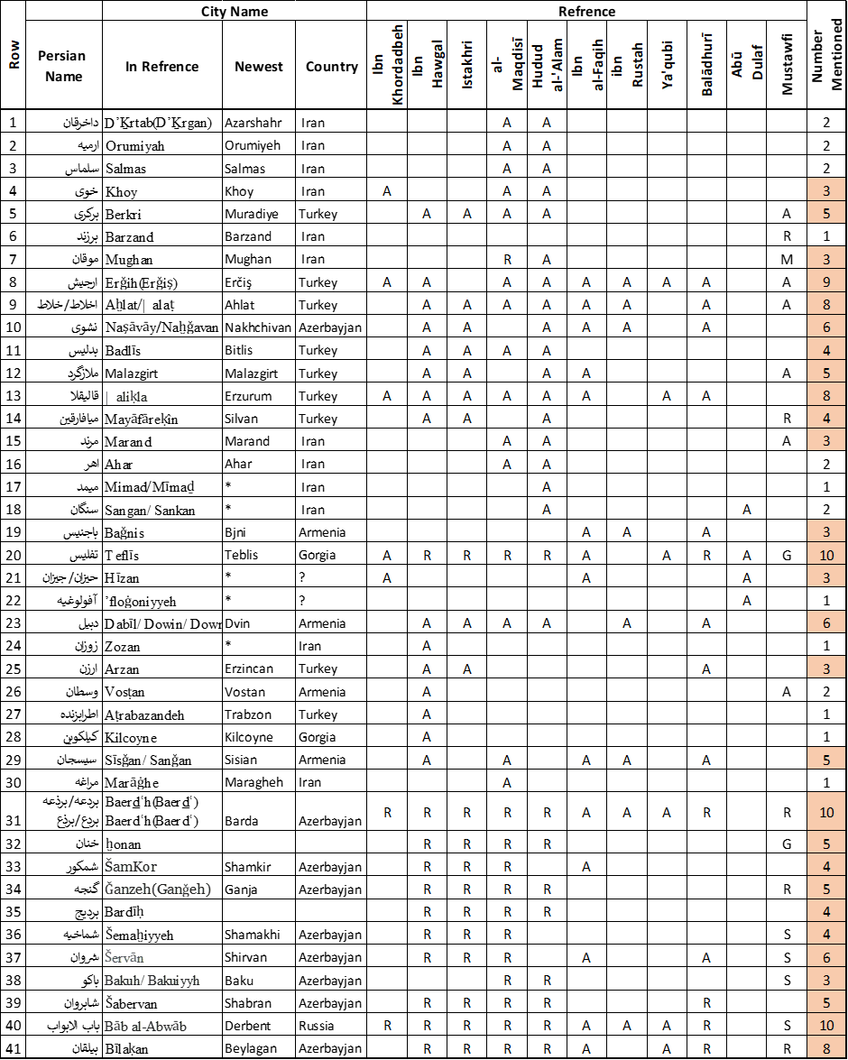
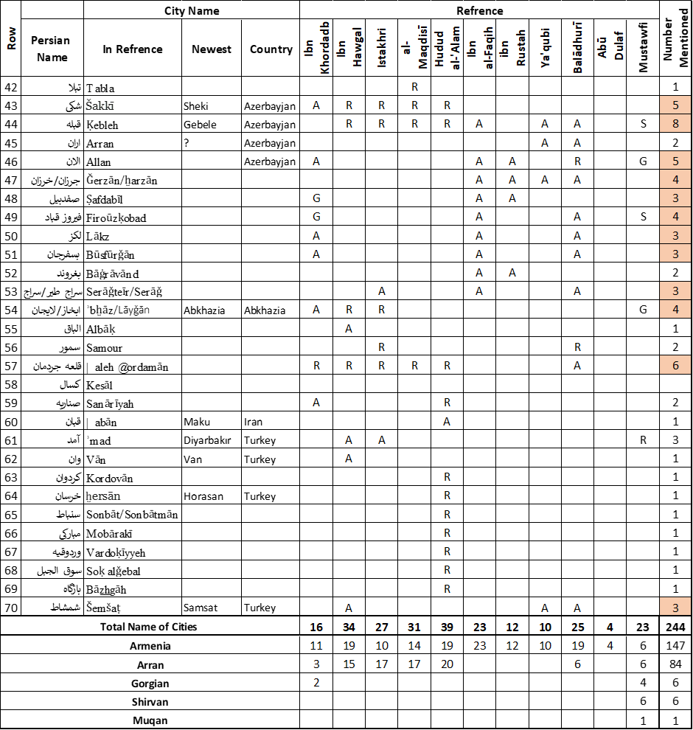
Table 1- Comparative list of cities based on sources.

Ya'qubi, Ibn Ishaq, Tārīkh al-Yaʿqūbī, (Beirut: Dar Sader, n.d)
Ibn Khaldun, History of Ibn Khaldun, (Beirut: Dar al-Fakr, 1998).

